Display GUI User Guide

First plug TTL232R-3V3 into the base station PCB and the computer

Information needed:

1. Communication port
2. Baud rate
3. Configuration file

Finding Communication Port

* Click on the start button at the bottom left corner.
* Go to devices and drivers
* Right click on the TTL232R-3V3 unspecified device and select properties
* Click on the hardware tab
* The communication port is listed (typically COM4)
* 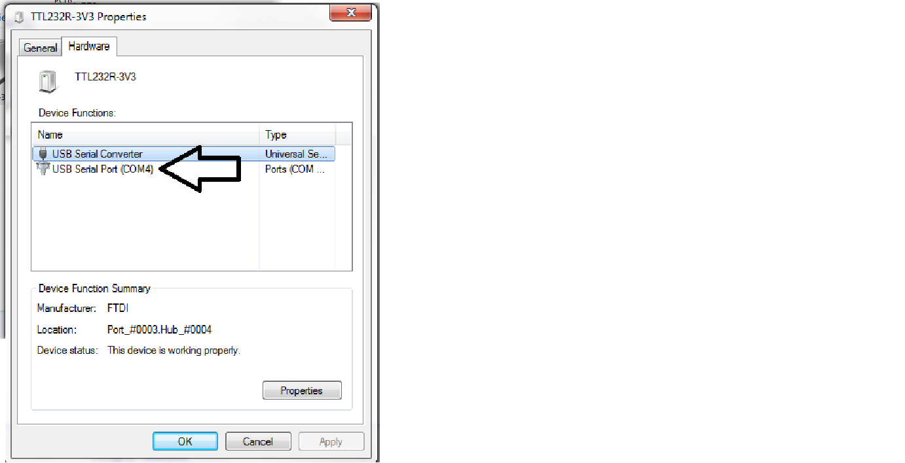

Baud Rate

* Baud rate is typically 38400 unless software manager changes

Configuration file

* Configuration file determines number of Nodes to be displayed on the Data Renderer and their corresponding locations
* The background image is defined within the configuration file
* 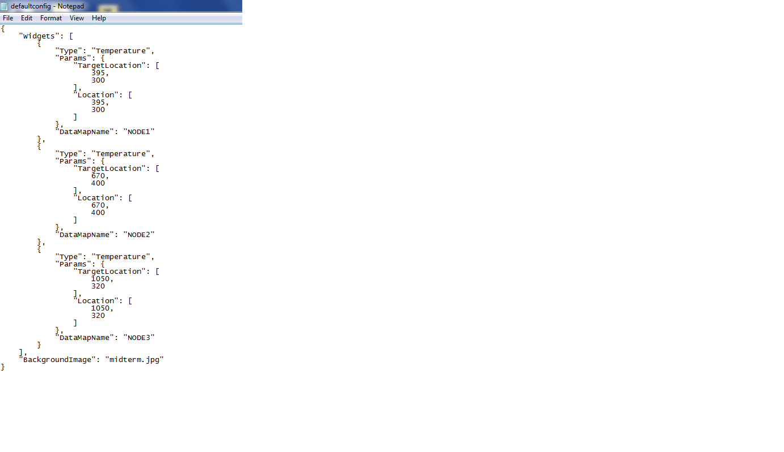

To start data renderer

* Open command prompt
  + A short cut for the command prompt has been pinned to the taskbar
* In the command prompt type:
  + python datarenderer.py <configuration file> <communication port> <baud rate>
* the typical command prompt should look like this:
  + python datarenderer.py defaultconfig.txt COM4 38400
  + 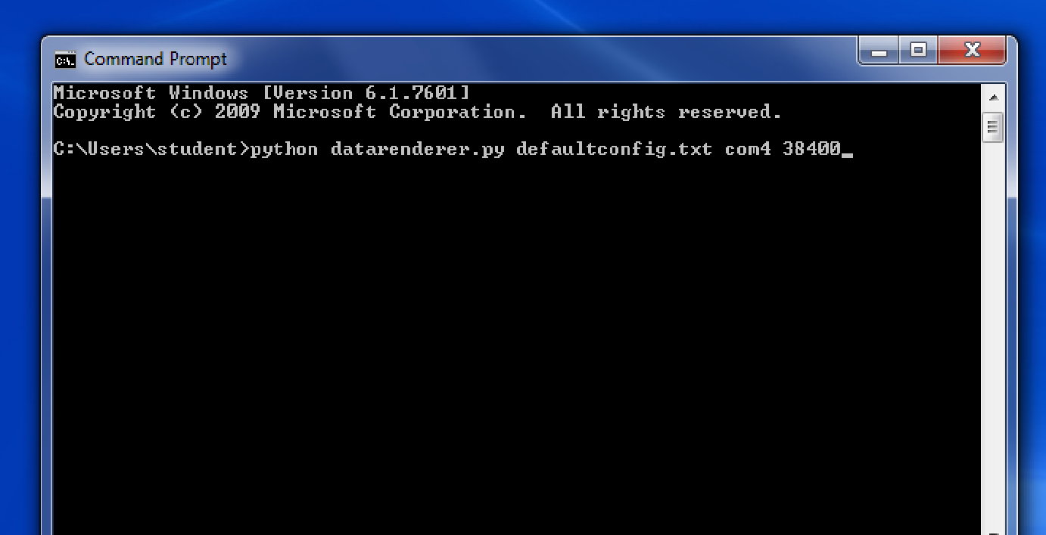
* hit enter
* data renderer display will open the following window
  + 